Mobile voting system Quick Start and Tutorial

Contents

Voting point installation: 1

Android application installation 2

Method 1 2

Method 2 3

Voting Point voting setup 4

To stop the elections 7

Registering for voting 8

Voting from the Android device 8

Advanced settings for the Voting Point Server 10

Setting the language 11

Certificates 11

Changing the server name in server advertisements 11

Changing the port numbers for the voting server 11

IP filtration 11

Result Presentation 12

Disable SSL 12

# Voting point installation:

WARNING: Prior to installation be sure you have OpenSSL installed, And have it in system path.

To install OpenSSL, please visit: <http://www.openssl.org/>, or run the installation files enclosed in the zip. “vcredist_x86.exe” first.

1. 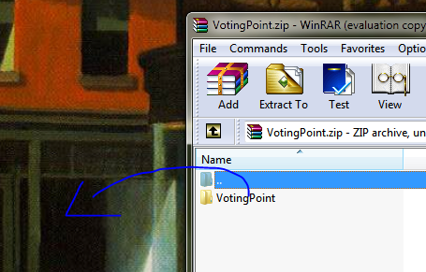Open votingPoint.zip.

Note that the extraction program on your system may vary.

1. Extract the files.
2. Launch MobileVotingDevice.jar (double-click, or from the command prompt enter “java –jar MobileVotingDevice.jar” when in the proper directory) .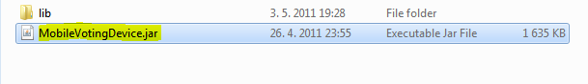

# Android application installation

## Method 1

Note: This method requires a computer and either a data cable from your device, or the ability to read micro SD cards.

1. 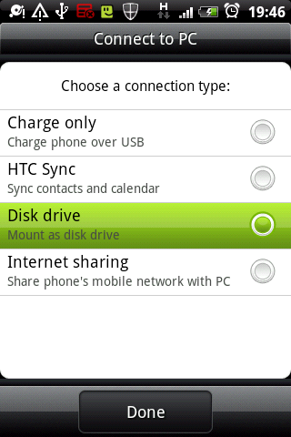Mount the SD card
   1. Via cable
      1. Plug the cable from your Android device into your computer.
      2. Plug the OTHER end of the cable into your Android device.
      3. When the device asks for a connection type, select Disk Drive.
   2. Direct SD card connection - you may need a micro SD to SD adapter
      1. Turn the Android device off, or unmount the SD card
      2. Insert the SD card into the appropriate slot on the computer.
2. Open the SD card folder.
3. Copy “Android Voter.apk” to the SD card.
4. Depending on your access method to the SD card, disconnect the device from the computer or remount your SD card.
5. 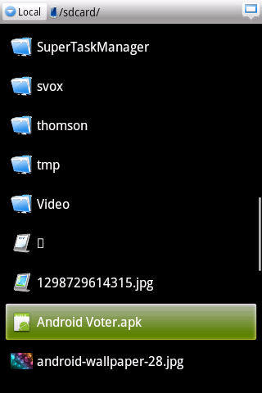Open your file manager. Note – if you do not have a file manager, there are plenty of free options on the Android® Market®. ES File Explorer is a good example, Astro File manager is another.
6. Locate the .apk file.
7. 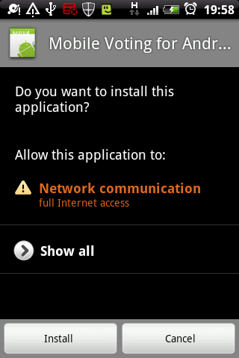Click on it.
8. Press install.
9. You’re done!

## Method 2

This method requires internet connection

1. If your device has a camera
   1. Install a QR code reader application – Barcode Scanner for example. https://market.android.com/details?id=com.google.zxing.client.android
   2. Scan the QR code.

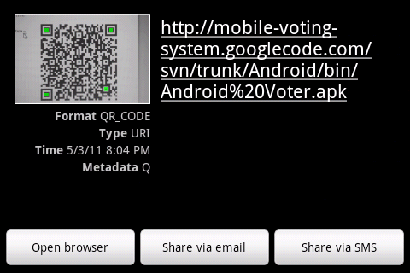The below screen should appear. Click Open Browser. Continue from Step 8, Method 1.

1. No camera on device? Do not panic.
   1. Open your browser.
   2. Insert ”http://mobile-voting-system.googlecode.com/svn/trunk/Android/bin/Android%20Voter.apk”, without the “” symbols.
   3. The device should recognize it is an app and install it as in step 8, Method 1.
2. Too complicated? We will publish on the Market soon.

# Voting Point voting setup

1. Create the Voting.

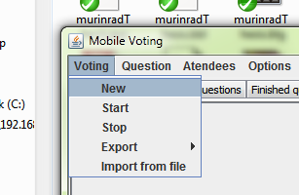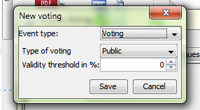

Select a validity threshold and type of voting. Do not change the event type. That function is not supported by this version.

1. Add voters.
   1. Method 1 – manually

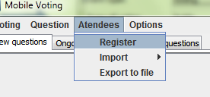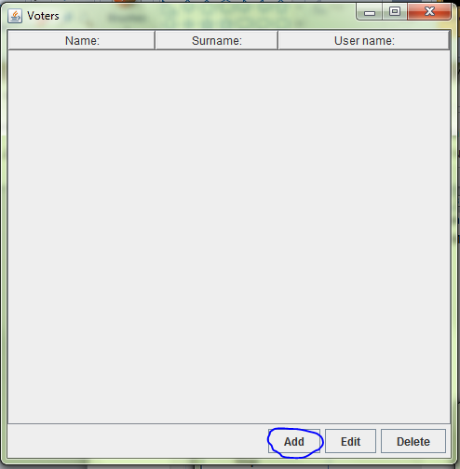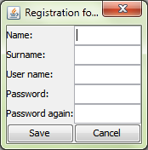

* 1. Using Prologue registration server
     1. Turn on voter registration.

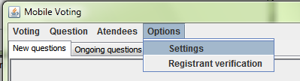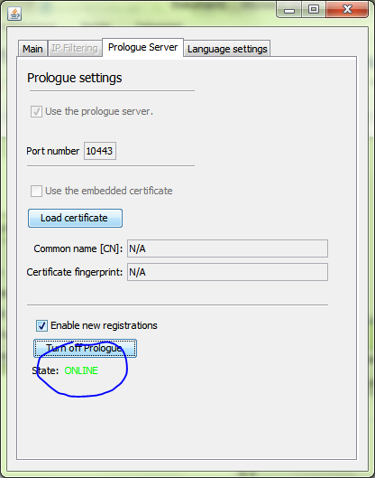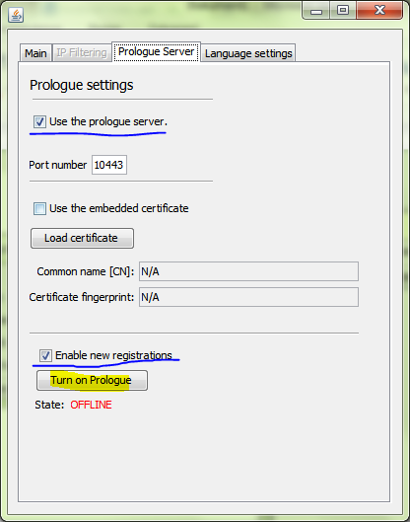

* + 1. If you wish to stop registrations, turn off Prologue. If you still want to provide an information website then deselect the “Enable new registrations” checkbox and turn prologue on.
    2. Turn on registrant verification, you can search for registrants by ID using the text field on the bottom, to give verification, double click.

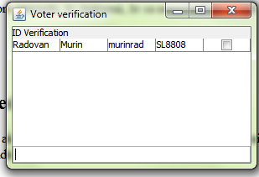

* + 1. Import voters/attendees as a file and look for file “approved.voters” in the root folder.

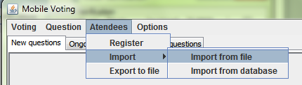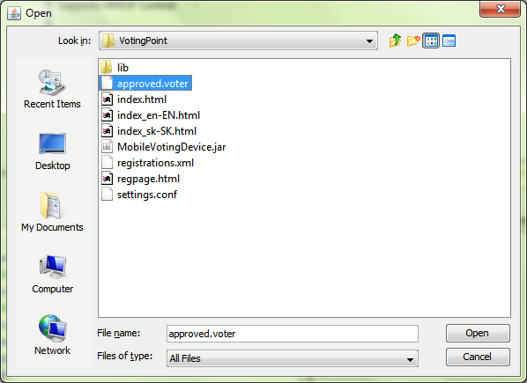

1. 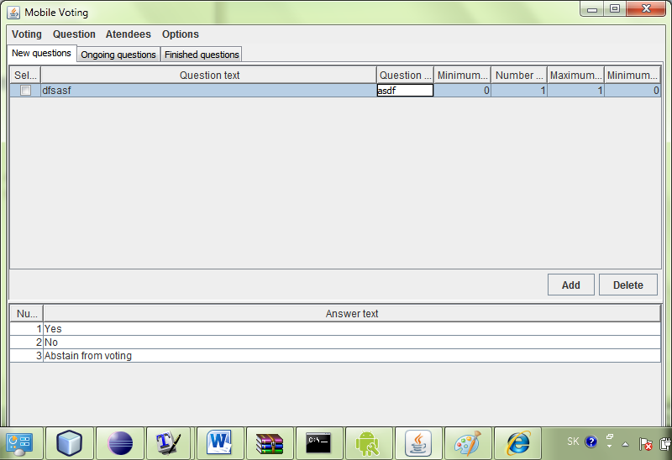Add questions
   1. Click add.
   2. Edit Question text and details – note you must fill out all the fields!!!
   3. Edit possible answers.
2. Start Voting
   1. Select the question you want to pose.
   2. Click Start .

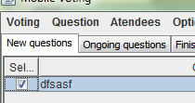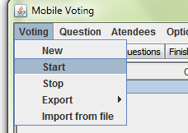

1. You’re done!

# To stop the elections

1. Click Voting – Stop.
2. View the results.
3. Post the results on a web server. (Optional)

# Registering for voting

1. Connect to the voting point web site via any web browser.
2. Follow the voter registration link. – This link should be given to you by a voting official.
3. Input data and press Submit.
4. You’re done!

# Voting from the Android device

1. Open the application, if it is a first run, it will prompt you for a master password, please input a password exactly 8 characters in length.
2. Input the master password and press OK.
3. Connect to a server.

**Tip: Don’t know the connection parameters? No trouble, the voting point server has an information webpage containing this info. Ask a commissioner nearby for its address.**

* 1. Situation : The server is not listed, and it did not appear automatically.
     1. Press menu click “New Server” .
     2. Input the relevant data, press menu again.
     3. Choose the desired action.

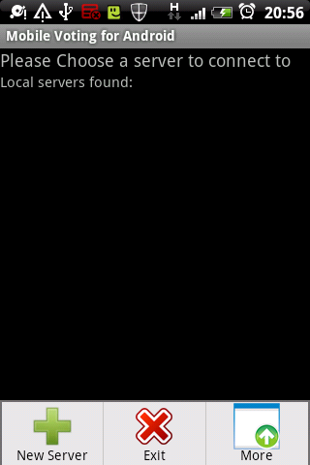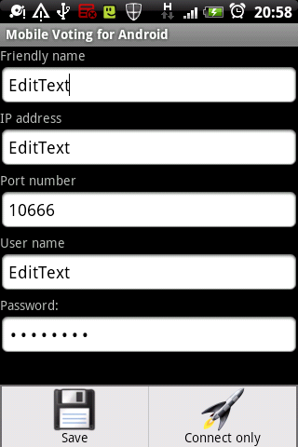

* 1. Situation: The server is listed in the “Local servers” category.
     1. Press the server, input credentials, proceeds as in Situation A, second step.
  2. Situation: I have previously connected to this server and the credentials are up to date and valid.
     1. Simply click the server you wish to connect to.
  3. Situation: I need to edit/delete server details.
     1. 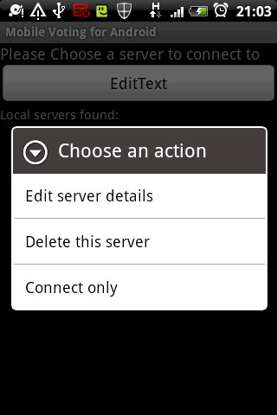Long press the server you wish to edit.

1. 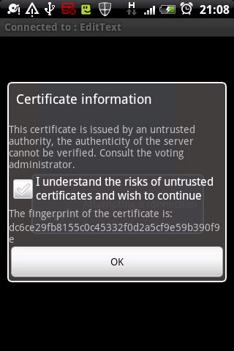If a certificate error appears, consult the action with the voting administrator. To confirm an exception you must check the checkbox.
2. When the questions appear, click on them to display possible answers.
3. 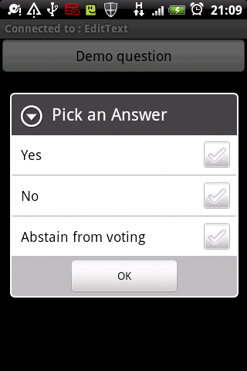Select the answer/s.
4. Press menu, click „Pick answers to send“, mark any answers to be sent, press menu again and click „Send answers“.
5. 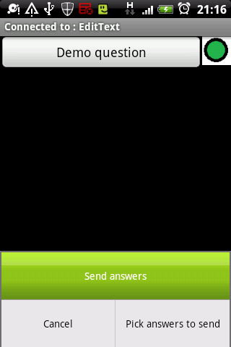You are done!

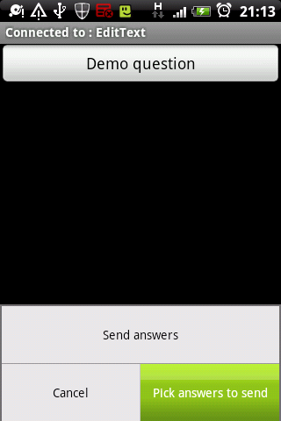Advanced settings for the Voting Point Server

# Advanced settings for the Voting Point Server

All settings are in Options -> Settings

## Setting the language

1. Go to the Language settings tab.
2. Select the language.
3. Press OK.

## Certificates

The application, by default uses an embedded certificate.

1. Go to Main tab.
2. Deselect “Use embedded certificate checkbox”.
3. Click load certificate, and load the certificate.
   1. NOTE: The proper certificate format is PKCS12!
4. Go to Prologue tab.
5. Deselect “Use embedded certificate checkbox”.
6. Click load certificate, and load the certificate.
   1. NOTE: The proper certificate format is PKCS12!

## Changing the server name in server advertisements

1. Main tab -> Server name

## Changing the port numbers for the voting server

1. Main tab -> Port number, Secure port number

## IP filtration

1. Open the main tab.
2. Select origin check.
3. Situation : You wish to use only simple filtration for the local LAN
   1. Select “Enable local connections only”.
   2. Note: This will enable connections only from private IPs:
      1. 10.0.0.0 /8
      2. 192.168.0.0/16
      3. 172.16.0.0/20
4. Situation: You are an experienced user and wish to filter traffic manually. Note: Use this only if you understand IP subnetting. This feature works much like ACLs, the connection is judged by the first matching rule.
   1. Select “Use advanced settings”.
   2. Open IP Filtering.
   3. Edit the rules.
   4. Close.

## Result Presentation

1. Stop the current voting process via voting->stop.
2. Click voting->export->export to HTML.
3. In the location selector, open the root directory of the application.
4. Create a directory, name it as you wish. The name will be referenced in this text as <DirName>.
5. Press OK.
6. Turn on Prologue. If it is already on, there is no need to restart.
7. The results are available at https://<server>:<port>/<DirName>/ .
8. NOTE: You CAN present any html website. Create websites and name them according the patterns in the documentation. Create a file called summary.sum, enter the names of the sites without the language suffixes, but with file suffixes. Put all these files into a folder.
   1. The folder should be accessible in the same way as the results.

## Disable SSL

1. SSL/TLS cannot be disabled in Prologue.
2. To disable SSL/TLS on the voting server, choose port 0.

Thank you for using the Mobile voting system.